Ideation Document for Individual Assignment

<https://git.fhict.nl/I500157/individual-assigment-semester-2>

This is the link to the GIT repository where I will upload my work and where you can find the project.

The goal of my project is to create a website where videogame players can upload their speedruns (a try to finish a game as fast as possible) and compare their tries against other players, like a leaderboard.

Every upload needs to be verified by an admin, using the Windows Forms app, where they can watch the video of the run to check if the run is legitimate or not.

If the run is marked as being real, it gets uploaded to the website. Otherwise, it will not be approved.

To upload a run to the website, you must create an account and to be logged in. Otherwise, you can view the records and the runs of the players if you’re not logged in.

The content of the app will be the runs which will be sorted after different options (for example: game, upload date, player etc.)

This is my initial idea for the project. But as the semester progresses, I will refine the idea into a professional project.

As a sitemap, this is what I envision for the moment. I will change it accordingly as I progress on the project.

As for the wireframes, these are a few examples of what my site would look like at the moment:

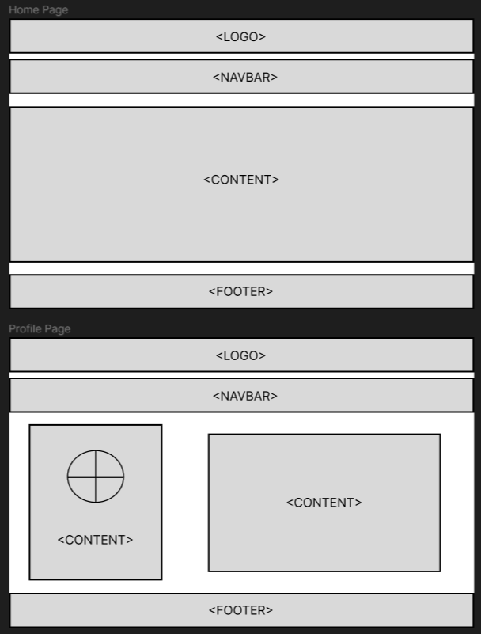

I hope that my ideas are good. I am openly waiting for feedback, especially for constructive criticism so I can work on it and become better.